AMP(2)-Lab06 – Oblique Collisions

# Content

# Learning objectives

## Exam objectives

By the end of this lab you should be able to (pen and paper):

* Consider all of the underneath frictionless and with the Newtonian assumption of **point particles** (read: no rigid-body aspects need to be taken into account), implying the kinetic energies as purely translational.
* Reveal the ‘next frame’ outgoing velocities (NFV) after an oblique 2D collisionwith either the **POC** (Plane Of Contact) **well-known**
* Reveal the ‘next frame’ outgoing velocities (NFV) after an oblique 2D collisionwith either the **POC** (Plane Of Contact) **unknown**
* Calculate the (loss of) kinetic energy before/after various collisions

We advise you to **make your own summary of topics** which are new to you.

## Supportive objectives

Specifically related to the above you should in GeoGebra Classic be able to:

* Calculate the kinetic energy before/after various collisions
* Calculate the ‘next frame’ outgoing velocities (NFV) after an oblique 2D collisionby linear system solving

# Exercises

Dependent of the lab session you may work individually or teamed (organized by the lab attendant). In either case make sure that throughout the course of this lab, you re-save sufficiently your solution file on your local machine as

**1DAExx-0y-name1**(+name2+name3).GGB given **xx**=groupcode, **0y**=labindex

Consider all of the underneath frictionless and with the Newtonian assumption of **point particles** (read: no rigid-body aspects need to be taken into account), implying the kinetic energies as purely translational.

## Basic exercises

### Exercise1

Two frictionless disks A and B given mA=1kg at vA=3m/s against mB=2kg at vB=1m/s obliquely collide with incoming velocity vectors as pictured.

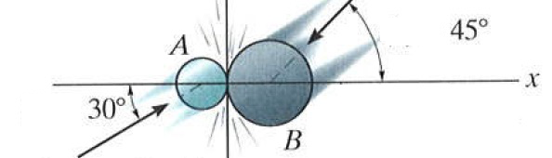

When their mutual coefficient of restitution is equal to 0.75, determine both outgoing velocity vectors via retrieving the x- and y-component of each, then calculating the magnitude and angle (with respect to the **LOI** x-axis) of each.

[ *uA=1.96* and $θ_{A}=130°$, *uB=1.41* and $θ_{B}=-30°$]

$$\left\{\begin{aligned}ε=\frac{u_{B}-u_{A}}{2}=0.75 \\ 1∙\left({3∙cos({45}^{°}) \atop 3∙sin({45}^{°})}\right)+2∙\left({-cos({30}^{°}) \atop -sin({30}^{°})}\right)=1∙u_{1}+2∙u_{2}\end{aligned}\right.$$

### Exercise2

A billiard ball collides at 2.2 m/s against an identical billiard ball at rest. Their collision occurs completely elastically. After the collision one ball has a speed of 1.1 m/s and its outgoing rectilinear motion subtends a 60° angle with the line of impact. Determine the other ball’s outgoing velocity by calculating its speed and subtended angle with respect to the line of impact.

[ *u=1.905* and $θ=30°$]

## Bridging exercises

### Exercise3

Checking the Law of Experimental Impact (determining the Coefficient Of Restitution $ε$) in an oblique way, we strike a ball to the floor with speed $v$ at an angle $α$ to the vertical. Now consider the outgoing velocity, for which we prove

* the rebound angle $β$ (at the other side of the vertical) satisfies

$$\tan{β}= \frac{1}{ε}\tan{α}$$

Which means that measuring both angles, determines the COR $ε$ as well.

* that the rebound speed equals

$$u= v \sqrt{ε^{2}{(\cos{α})}^{2}+{(\sin{α})}^{2}}$$

[To prove each of the above: determine both vectors, the incoming velocity $\vec{v}$ and the outgoing velocity $\vec{u}$ by their components based on the LOI and the POC]

## Contextual practice

### Exercise4

A 0.5 kg ball is ejected horizontally from the tube at $A$ with a speed of *vA=2m/s*. The coefficient of restition between ball and the soil colliding in $B$ reads $ε=60\%$.

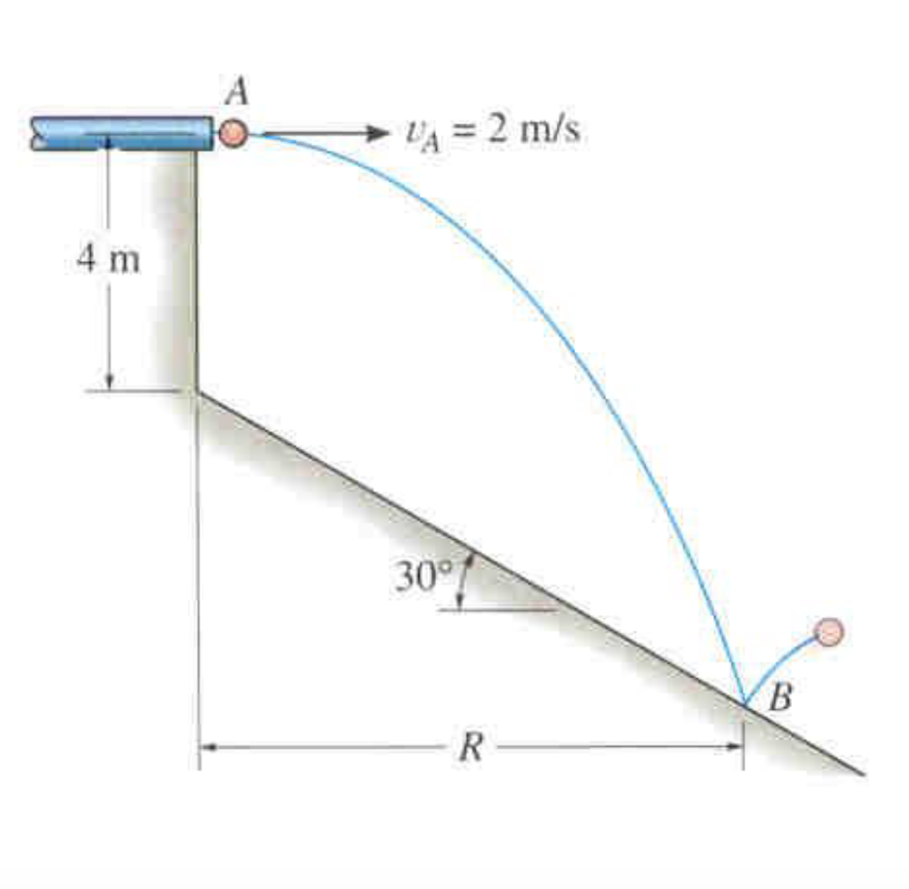

* Find the distance $R$ where the ball strikes the smooth inclined plane

Choose the y-axis along the slope (POC) oriented uphill and the x-axis perpendicular (LOI) to the y-axis in the point $B$ (local origin) oriented upwards.

* Determine the outgoing velocity vector $\vec{u}$ by its x- and y-components.
* Calculate the outgoing speed by which the ball bounces from the plane.
* Retrieve the angle to the x-axis by which the ball bounces from the plane.

[the horizontal distance $R=2.06 m$, *uA=8.21 m/s*, $-55.6°$ from the x-axis in $B$]

# References

## Links

<https://www.youtube.com/watch?v=7_nKOET6zwI> (first 11minutes)

## Extra practice

Physics NE/6, D.C.Giancoli (Pearson Education, 2014) pp 216-218